**Database Assignment 2**

Note : Use Emp, dept and salgrade table

1. To list all records with sal > 2000 and comm>200

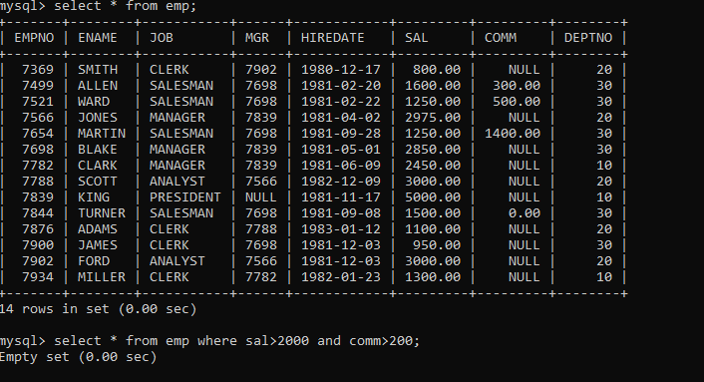

1. To list all record with job=’Clerk’ or sal>2000

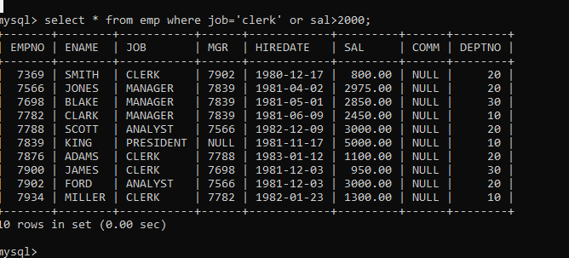

1. To list all the record with sal=1250 or 1100 or 2850

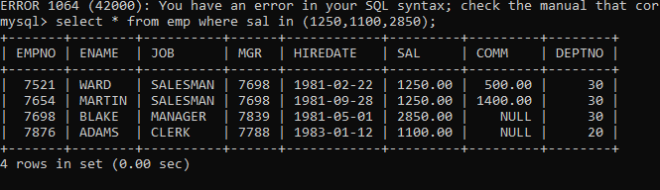

1. To list all employees with sal>1250 and <2850

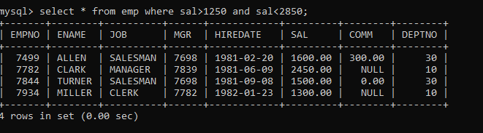

1. To list all employees with name ends with AS

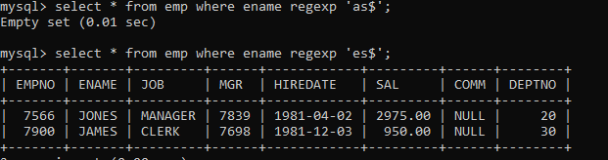

6. To list all employees with job starts with C and ends with K

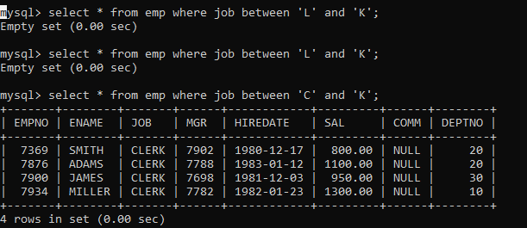

1. To list all employees with job contains L at third position and M at third last position.

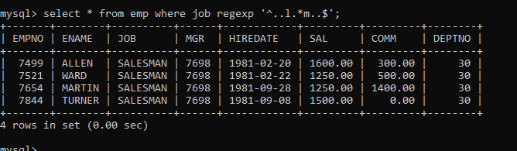

7. To list all the record with sal not equal to 1250 or 1100 or 2850

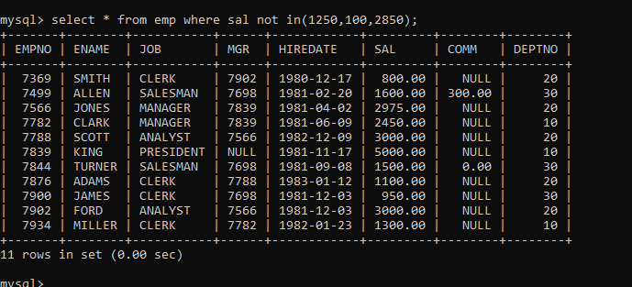

9. To list all employees with sal not >1250 and <2850

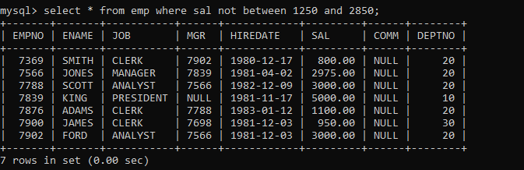

10. To list all employees with job starts with C , E at 3rd position and ends with K

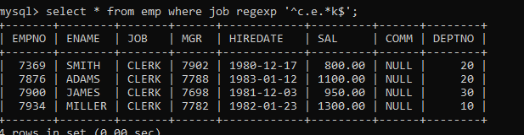

11. To list all rows with comm is null

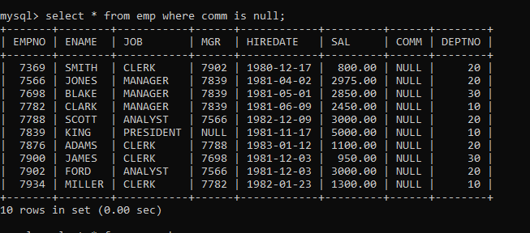

12. To list all employees with sal is null and name starts with ‘S’

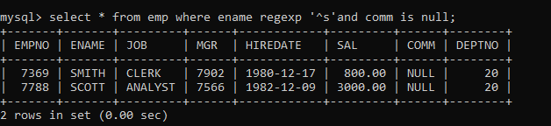

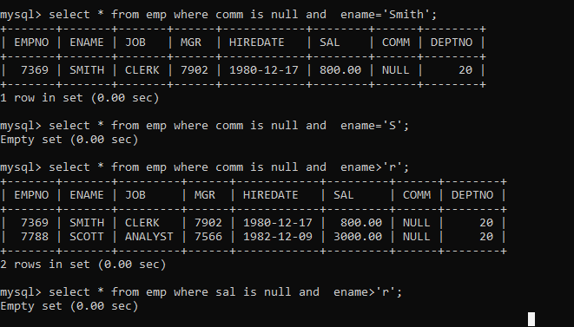

13. To list all employees with job contains 5 characters

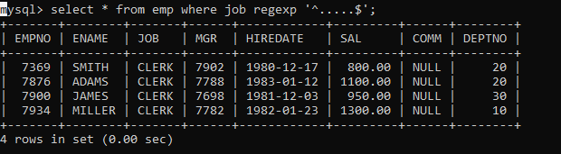

14. To list all employees with name contain ‘A’ at 1 position and job Contains 5 characters

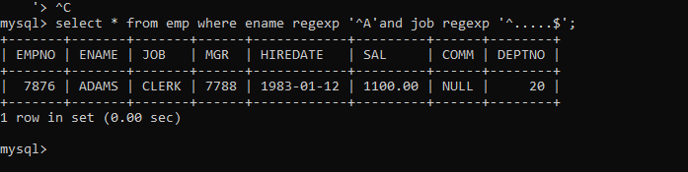

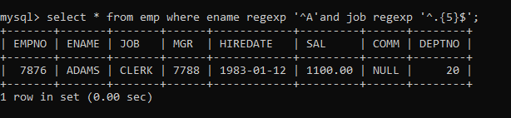

Single Row functions

1. To list all employees and their email, to generate email use 2 to 5 characters from ename

Concat it with 2 to 4 characters in job and then concat it with ‘@mycompany.com’

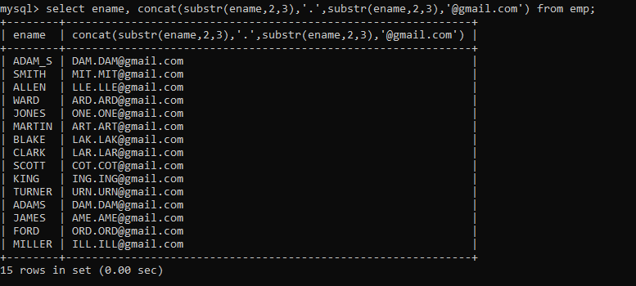

2. List all employees who joined in September.

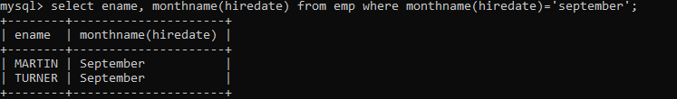

3. List the empno, name, and department number of the emp who have experience of 18 or

more years and sort them based on their experience.

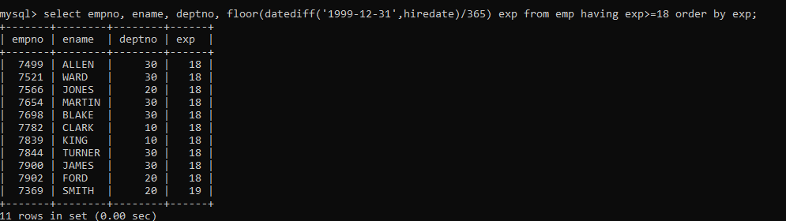

4. Display the employee details who joined on 3rd of any month or any year

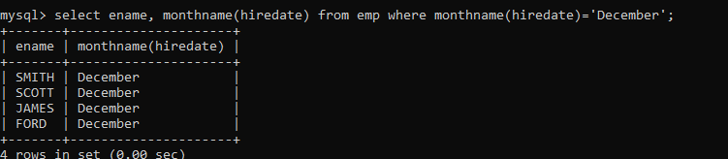

5. display all employees who joined between years 1981 to 1983.

